By Rentian Dong and Zhiyu Xiong

1)
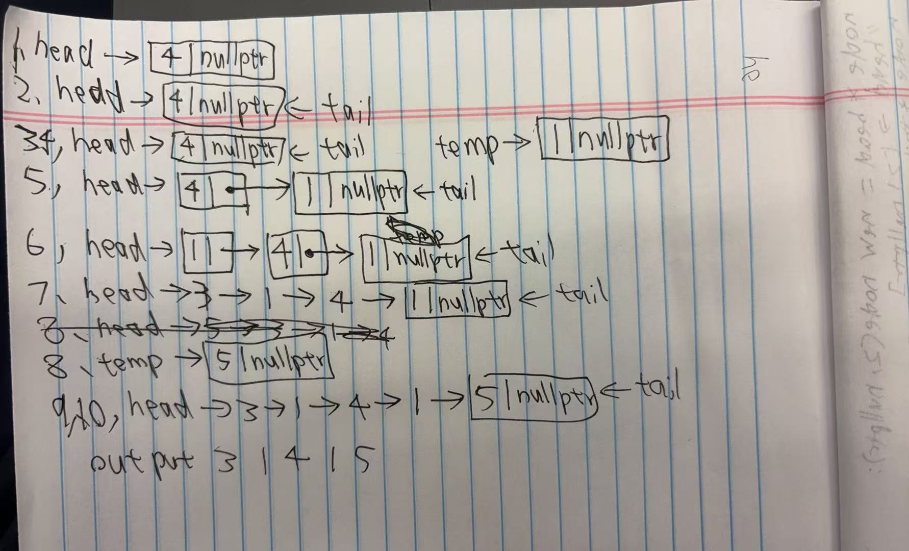
2)
std::size_t list_index(node* head_ptr, int target) {
size_t index = 0;
const node* curr = head_ptr;
while (curr != nullptr) {
if (curr->data() == target) {
return index;
}
else {
index++;
curr = curr->link();// 移动到下一个节点
}
}
return -1;//it will wrap around to the max of size_t
}

3)
node* list_at(node* head_ptr, std::size_t n) {
node* curr = head_ptr;
size_t track = 0;
while (curr != nullptr) {
if (track == n) {
return curr;
}
else {
track++;
curr = curr->link();
}
}
return nullptr;
}

4)
//This is a silly way because it is inefficient, in the for loop, every time i++, list_size(head) and list_at(head, i) both works again, so inefficient.

5)
//link list would be more efficient in modifying elements because the new value can just be simply put after the tail with nullptr, for an array we have to increase size, reallocate array and copy the values to add one single value
//array would be more efficient in accessing elements because simply using [] can return the value, link list has to do extra work

testing program)
int main() {
node* head = new node(4, nullptr);
node* tail(head);
node* temp;
temp = new node(1, nullptr);
tail->set_link(temp);
tail = temp;
head = new node(1, head);
head = new node(3, head);
temp = new node(5, nullptr);
tail->set_link(temp);
tail = temp;
//3 1 4 1 5

// test list_index()
cout << "list_index" << endl;
cout << list_index(head, 1) << endl; //output: 1

cout << "\nlist_at" << endl;

// test list_at()
node* temp0 = list_at(head, 0);
cout << "index 0: " << temp0->data() << endl; //output: 3

return 0;
}

